

**MALIGNANT COMMENTS CLASSIFICATION**



Submitted by:

SACHIN GUPTA

**ACKNOWLEDGMENT**

Working on this project has an incredible experience that will have an impact on my career to get a strong depth of Knowledge about real time Projects .

It is pleasant gratification to present Malignant comment classification.

I have completed this project by taking the help from Google, Bing and You tube.

**INTRODUCTION**

##### *The conversational of social media is an issue that can lead people both to stop genuinely expressing themselves and to stop seeking others opinions out of fear of abuse and harassment. However, at the same time, this has resulted in the emergence of conflict and hate, making online environments uninviting for users.*

##### *There has been a remarkable increase in the cases of cyberbullying and trolls on various social media platforms*

The goal of this project will be use to identify comments in text, which could be used to help deter users from posting potentially hurtful messages, craft more civil arguments when engaging in discourse with others, and to gauge the other users comments.

##### *There has been a remarkable increase in the cases of cyberbullying and trolls on various social media platforms.*

##### *Online hate, described as abusive language, aggression, cyberbullying, hatefulness and many others has been identified as a major threat on online social media platforms.*

##### *Our goal is to build a prototype of online hate and abuse comment classifier which can used to classify hate and offensive comments so that it can be controlled and restricted from spreading hatred and cyberbullying.*

**Importing Libraries:**

*I am importing all the library which I required for EDA, visualization, prediction and finding all matrices. The reason of doing this is that it become easier to use all the import statement at one go and we do not require to import the statement again at each point***.**

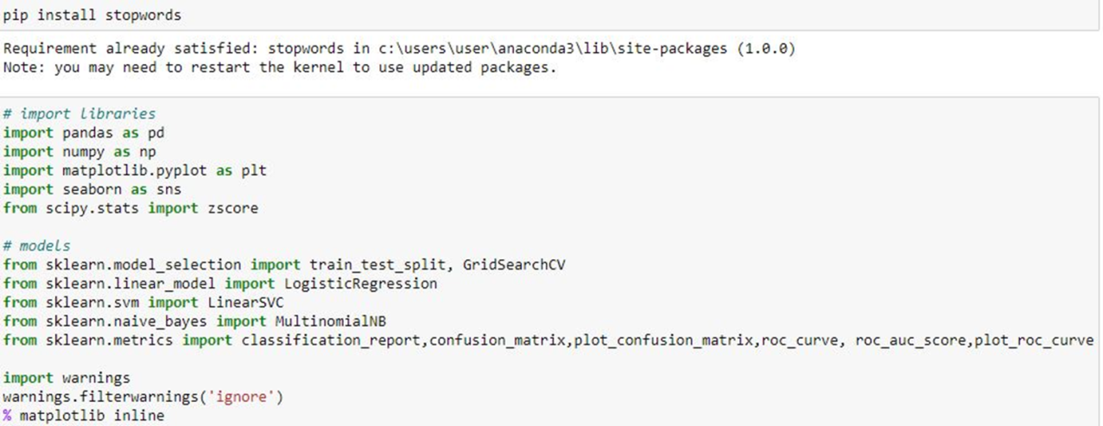

* Data Sources and their formats

Now I am going to upload data-sets using pandas. For this I used read csv method. By Loading Malignant Classifier dataset I got the idea about the head of the Project.

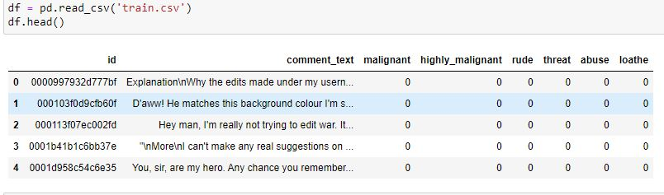



By using shape I understand that in this dataset there are 159571 rows & 8 columns.

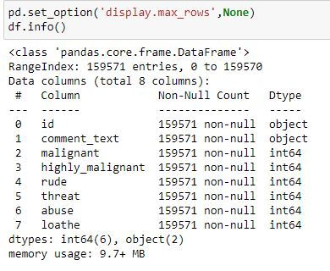

From this coding in this dataset I can see that all the columns counts are matching.

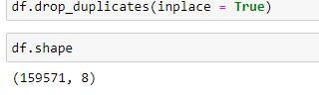

In this Dataset I got no Duplicates.

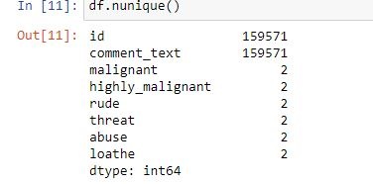

From using Unique Code I can see 2 columns are continuous and remaining columns are categorical.

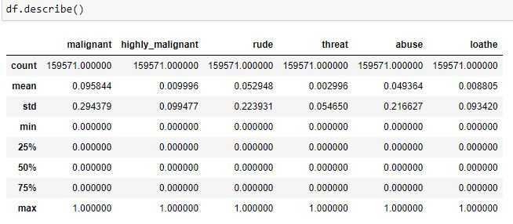

From this Describe Column I can see there is a difference between mean and 50% value in some of the columns which used to get fix for better prediction.

Also, the mean and 50% value of most of the column are not same and the STD and mean have a major difference to each other.

**Data Visualizations**

Donut charts

A donut chart is almost identical to a pie chart, but the center is cut out (hence the name 'donut').

Donut charts are also used to show proportions of categories that make up the whole, but the center can also be used to display data.

Pie charts

Pie charts can be used to show percentages of a whole, and represents percentages at a set point in time.

Count Plot

Count Plot is used to Show the counts of observations in each categorical bin using bars.

To create a horizontal bar chart or countplot in sea born, you simply map your categorical variable to the y-axis (instead of the x-axis).

When you map the categorical variable to the y-axis, Sea born will automatically create a horizontal countplot.

**MALIGNANT**

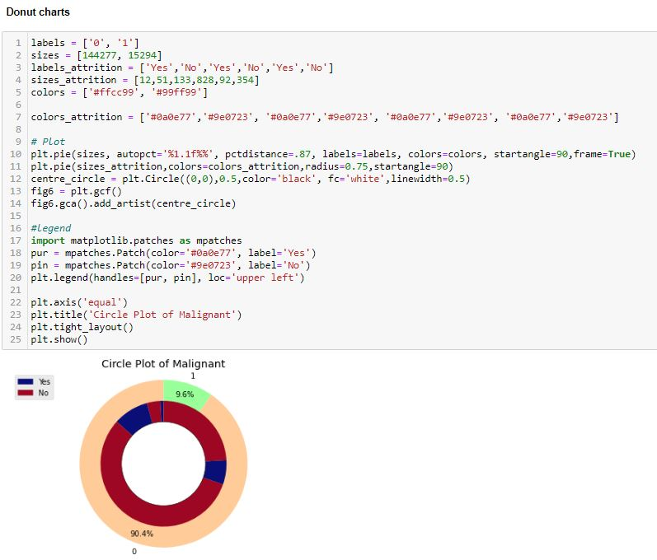

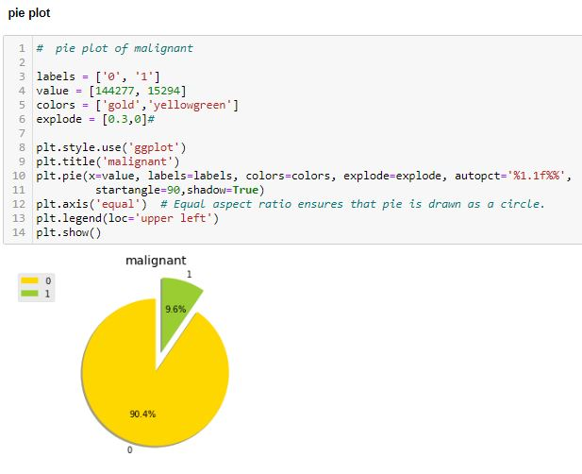

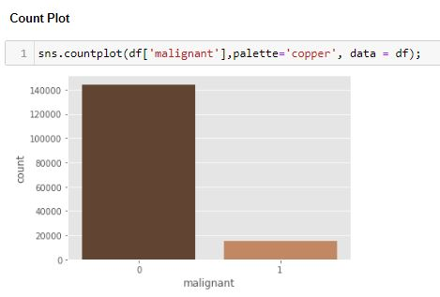

From this Donut Charts it shows 90.4% people gives malignant comments in online Platform which is very harmful for the society.

From the Pie Plots I can visualize that value depicting 90.4% which comments are malignant in nature.

Count Plot Defines 90.4% peoples in social media gives harsh comments which effects the individuals.

**HIGHLY MALIGNANT**

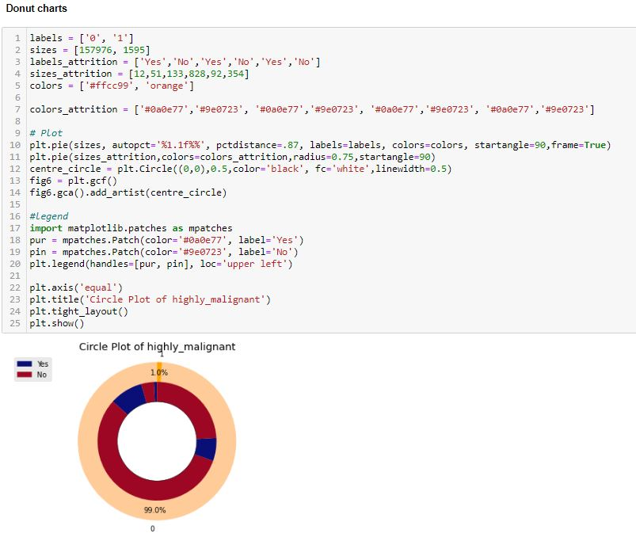

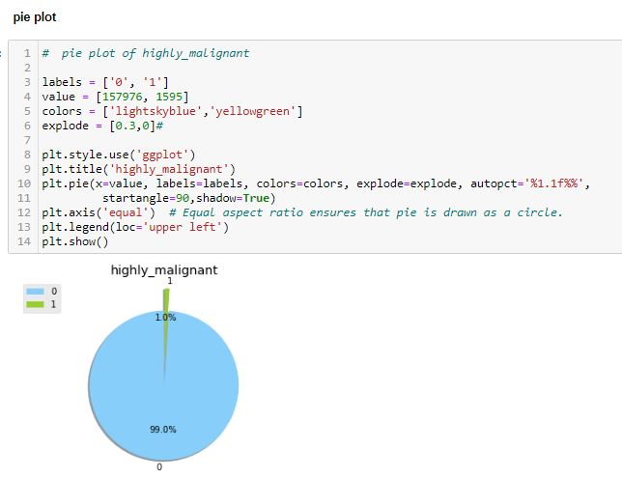

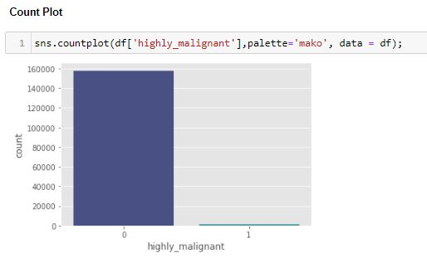

Highly malignant: It is the Label column, which includes values 0 and 1, denoting if the comment is highly malignant or not.

157976 represent not highly malignant comment and only 1595 are malignant.

**RUDE**

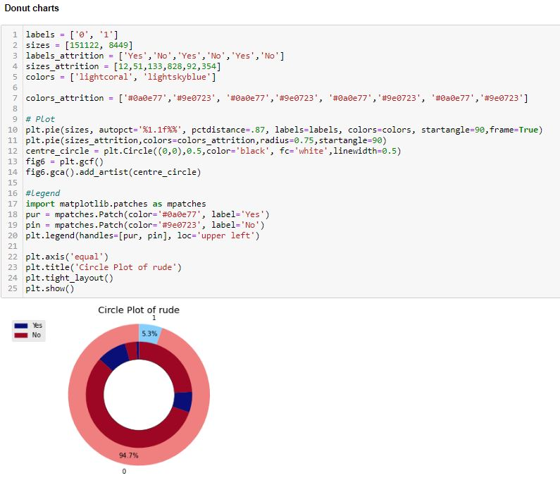

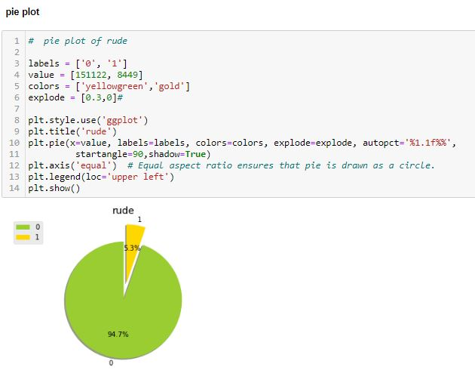

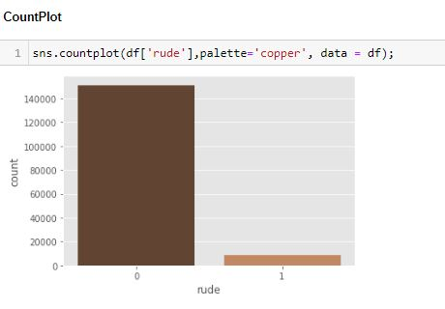

Rude: It denotes comments that are very rude and offensive. 151122 represent not rude comment and only 8449 are rude

**THREAT**

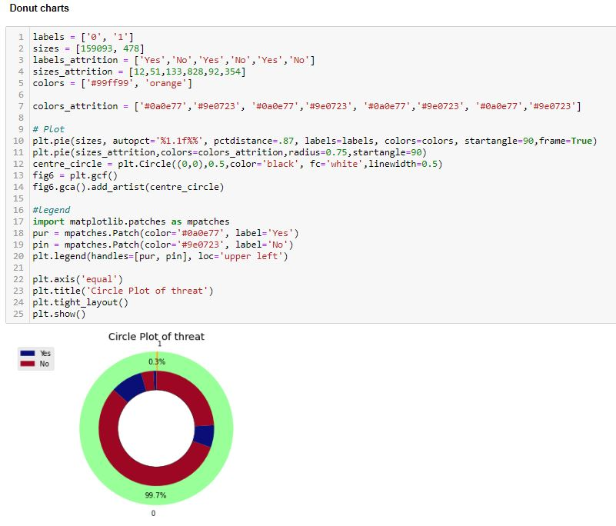 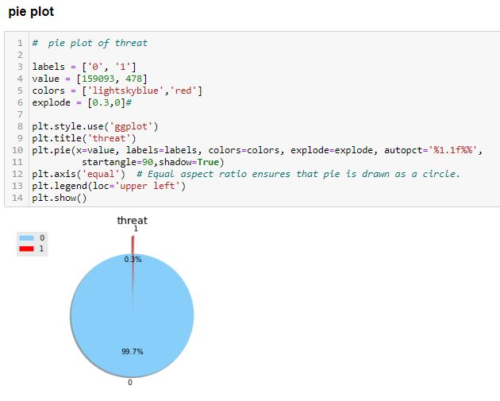

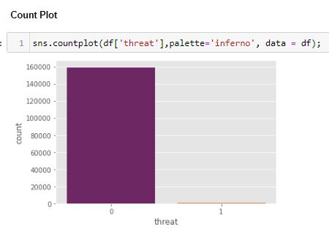

Threat: It contains indication of the comments that are giving any threat to someone.

159093 represent not threat comment and only 478 comments are threat type.

**ABUSE**

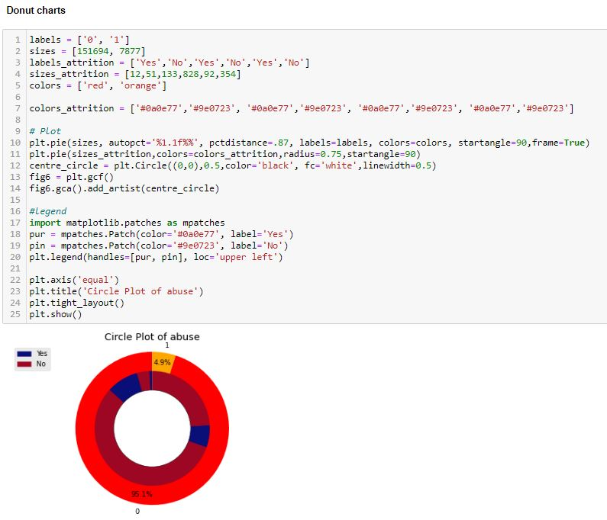

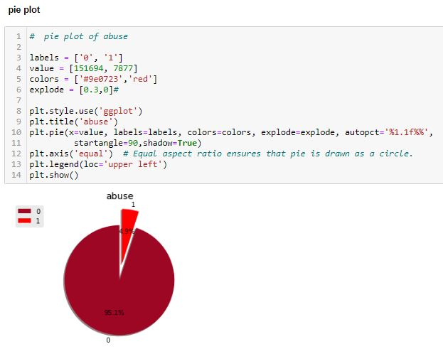

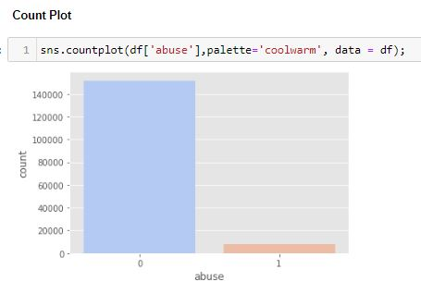

Abuse: It is for comments that are abusive in nature.

159093 represent not threat comment and only 478 comments are threat type.

**LOATHE**

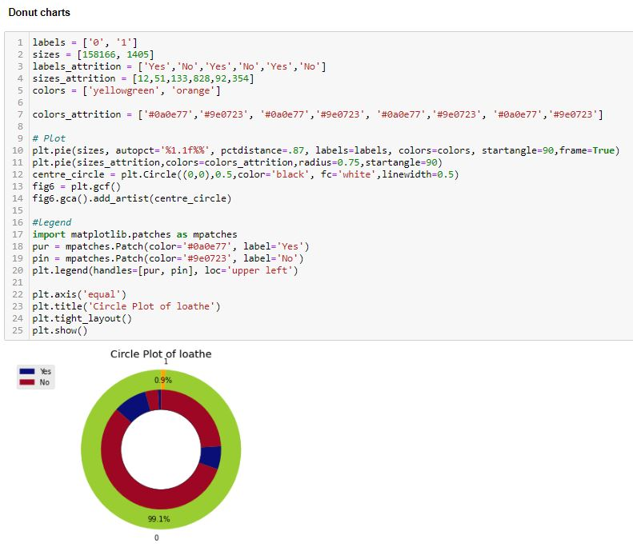

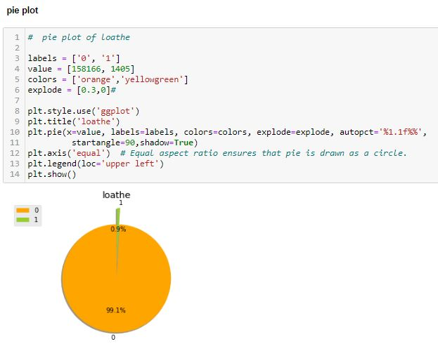

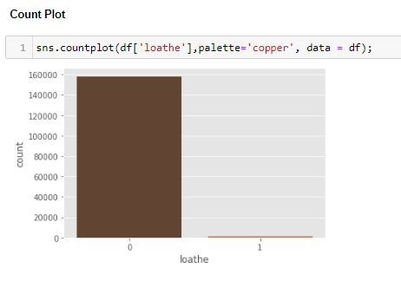

Loathe: It describes the comments which are hateful and loathing in nature.

158166 represent not loathe comments and only 1405 comments are loathe type.

**Correlation**

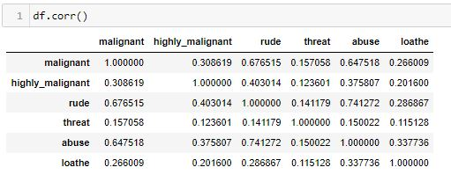

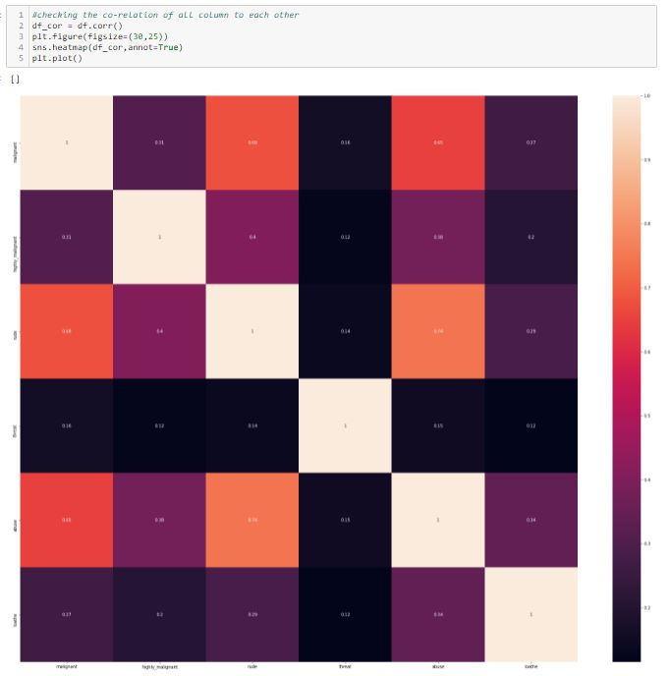

Heatmap is a way to show some sort of matrix plot. To use a heatmap the data should be in a matrix form. By matrix we mean that the index name and the column name must match in some way so that the data that we fill inside the cells are relevant.

**COMMENT TEXT COLUMNS**

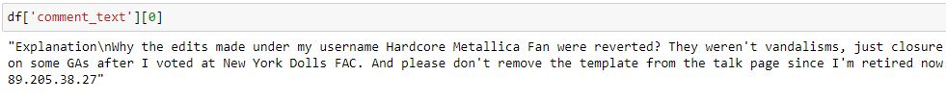

Comment text columns contains the information of all the comments in the features variable.

**NATURAL LANGUAGE TOOLKIT**



I have import nltk that is Natural Language Toolkit which help me to inbuilt all the libraries in one go.

**STOPWARDS**

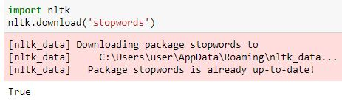

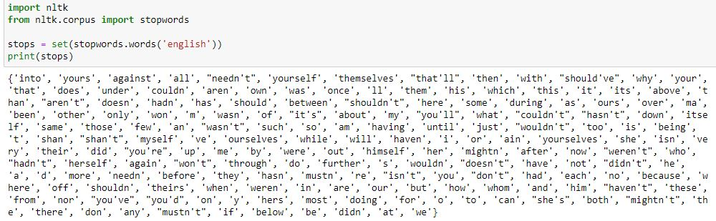

I have import stopwards that help me to identify all the common words which i can remove it from comments columns.

**LEMMATIZATION & STEMMING**





Lemmatization is the process of converting a word to its base form.

The difference between stemming and lemmatization is, lemmatization considers the context and converts the word to its meaningful base form, whereas stemming just removes the last few characters, often leading to incorrect meanings and spelling errors.

**REGULAR EXPRESSION**



Regular expressions are typically used in applications that involve a lot of text processing.

For example, they are commonly used as search patterns in text editing programs used by developers, including vi, emacs, and modern IDEs

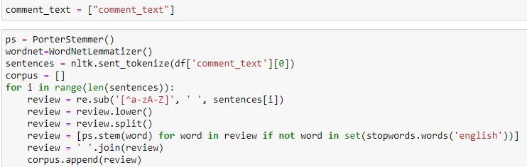

I have used the Porter Stemmer and Word Net Lemmatizer in comment text columns so that i can minimize the numbers of words from the columns and get some meaningful information out of it. It will also help us to improve the accuracy score.

**COUNT VECTORIZER**



I have Created the Bag of Words model for model prediction. This will convert the words into numbers.

**LABELS COLUMNS**



I have put all the labels in dictionary for model buildings.

**MODEL BUILDING**



I have used 33% for testing and 67% for training purpose.

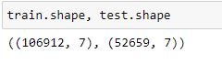

There are 106912 rows and 7 columns will be used for training purpose and remaining 52659 rows and 7 columns will be used for testing purpose.

**MULTINOMIAL NAÏVE BAYES**

Multinomial Naive Bayes algorithm is a probabilistic learning method that is mostly used in Natural Language Processing (NLP).The algorithm is based on the Bayes theorem and predicts the tag of a text such as a piece of email or newspaper article.It calculates the probability of each tag for a given sample and then gives the tag with the highest probability as output.Naive Bayes is a powerful algorithm that is used for text data analysis and with problems with multiple classes. To understand Naive Bayes theorem’s working, it is important to understand the Bayes theorem concept

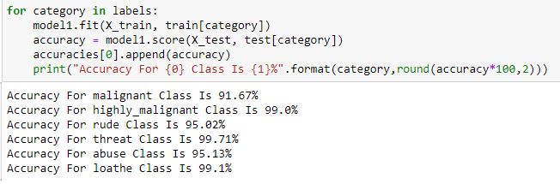

## **Linear Support Vector Classifier**

Linear Support Vector Classifier is a supervised machine learning algorithm which can be used for classification problems..

It uses a technique called the kernel trick to transform your data and then based on these transformations it finds an optimal boundary between the possible outputs.

The algorithm creates a line or a hyperplane which separates the data into classes.

## 

## **Logistic Regression**

Logistic regression is basically a supervised classification algorithm.

Logistic Regression is a classification technique used in machine learning.

It uses a logistic function to model the dependent variable.

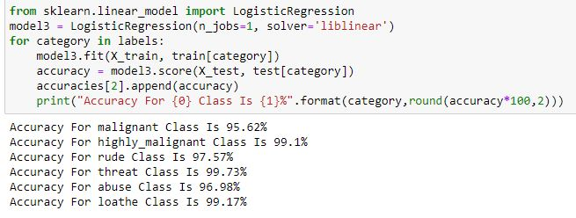

**AGGREGATE ACCURACY**

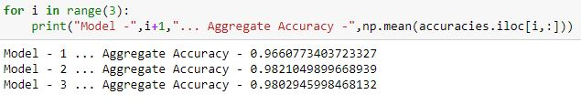

I have used 3 model for model prediction and after doing the aggregate the best model accuracy is 98.21% that is Linear Support Vector Classifier.

**Saving The Best Model**

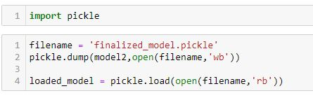

As Linear Vector Classifier is giving the highest value in this dataset so this is the best model to save it.



**Interpretation of the Results**

* I have used visualization tool such as count Plot to understand the data in a better way.
* I used describe method for five-point summary analysis and also found the number of rows and columns in dataset.
* I have done the model building with 3 algorithms and the best model is Linear Support Vector Classifier with an accuracy score of 98.21%

**CONCLUSION**

* I have managed out how to prepare a model that gives users for a novel best approach at future lodging value predictions.
* I have train dataset from which I had to extract information.
* I had used pandas library to read the Dataset which provide me to explore & visualize the Data properly based on Rows & Columns.
* I did exploratory data analysis on main data frame and tried to see all visualizations.
* Based on visualization knowledge, I use various EDA TECHNIQUES to plot the count plot.
* After from all these I split the Features & Labels into 2 parts.
* On this data, I have applied our machine learning classification models such as Logistic regression, Linear Support Vector Classifier and Multinomial Naive Bayes train dataset.
* ) After which I found Linear Support Vector Classifier has the High accuracy score(98.21%) and best among all the regressor models.